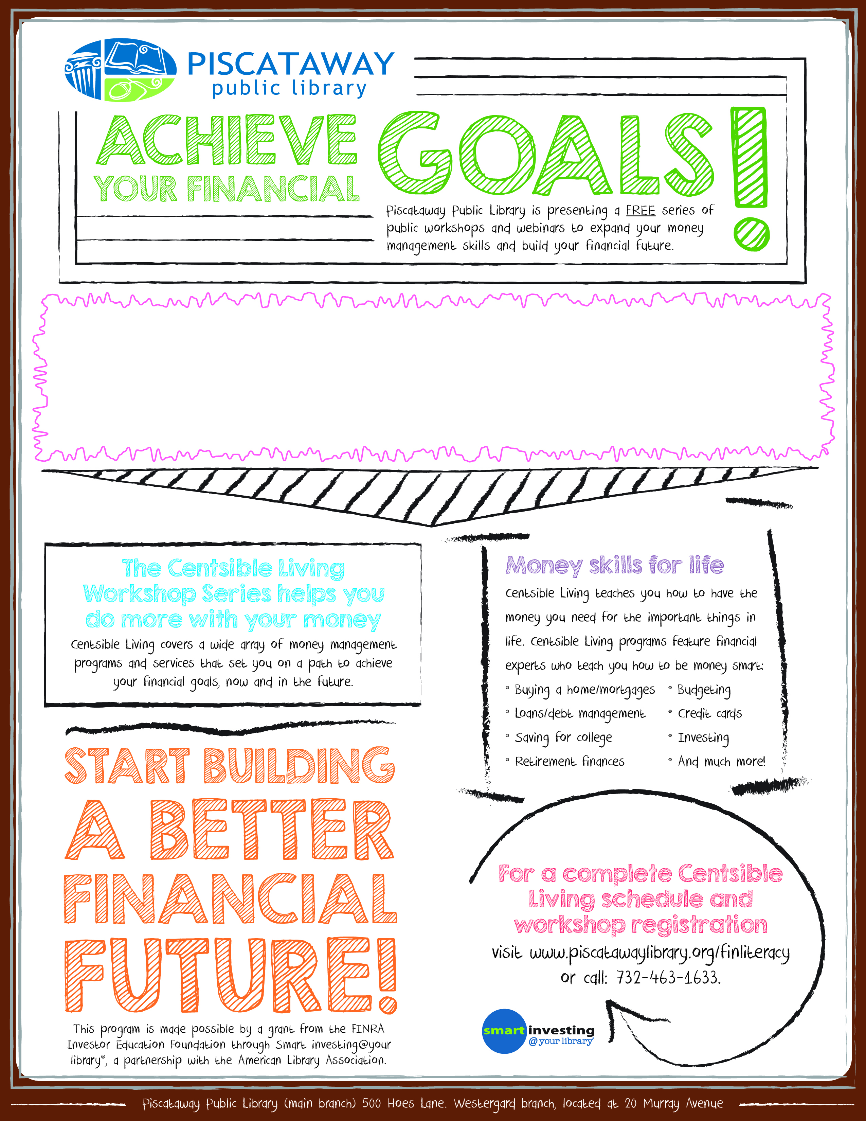

**How Are You Doing? Give Yourself a Financial Check-Up**

Wed, Oct. 22, 2014 - 6:30pm to 8:15pm - Piscataway High School-Rm. F-100. Learn 20 different ways to assess your personal finances, includingfinancial goal-setting, income and expense statements, net worth, debt ratios, marginal income tax brackets, retirement planning, investment and performance metrics, investment risk tolerance, insurance needs, estate planning, government financial statistics, financial quizzes, and more. Register by calling 732-463-1633x6.Refreshments will be served.